ORDINANCE NO. O2025-019
AN ORDINANCE OF THE CITY COUNCIL OF THE CITY OF YUMA, ARIZONA, AMENDING CHAPTER 154 OF THE YUMA CITY CODE, AS AMENDED, RELATING TO ZONING REGULATIONS, PROVIDING FOR CHANGES TO THE ZONING CODE TO AMEND DEVELOPMENT REGULATIONS AND EXPAND THE PERMITTED ZONING DISTRICTS FOR ACCESSORY DWELLING UNITS

WHEREAS, from time to time it may be desirable to modify the zoning code within the context of a dynamic and growing community; and,

WHEREAS, the City of Yuma Planning and Zoning Commission held a public hearing on April 14, 2025 in Case no: ZONE-43748-2025 in the manner prescribed by law for the purpose of amending the City of Yuma Zoning Code; and,

WHEREAS, due and proper notice of the public hearing was given in the time, form, substance and manner provided by law, including publication of notice of the hearing in the Yuma Sun on March 21, 2025; and,

WHEREAS, the City Council has considered the recommendation of the Planning and Zoning Commission to approve the zoning code text amendment in Case No: ZONE-43748-2025 and the probable impact on the cost to construct housing for sale or rent that may occur as a result of this amendment, and finds that the recommendation complies with and conforms to the goals and objectives of the Yuma General Plan, as amended.

NOW THEREFORE, BE IT ORDAINED by the City Council of the City of Yuma as follows:
SECTION 1: Yuma City Code, Title 15, Chapter 154, Article 5, Section 5, Low Density Single-Family Residential District (R-1-5), Subsection D, is amended to insert the bolded text:
(4) Accessory dwelling units.
SECTION 2: Yuma City Code, Title 15, Chapter 154, Article 6, Section 1, Residence-Manufactured Housing District (R-MH), Subsection D, is amended to insert the bolded text:
(2) Accessory dwelling units.
SECTION 3: Yuma City Code, Title 15, Chapter 154, Article 6, Section 2, Recreation Vehicle Subdivision District (RVS), Subsection D, is amended to insert the bolded text and renumber the following subsections:
(D) Permitted accessory uses.
(1) Accessory dwelling units.
SECTION 4: Yuma City Code, Title 15, Chapter 154, Article 6, Section 3, Manufactured Housing Subdivision District (MHS), Subsection C, is amended to insert the bolded text:
(5) Accessory dwelling units.

SECTION 5: Yuma City Code, Title 15, Chapter 154, Article 7, Section 2, Medium Density Single-Family Residential District (R-2-5), Subsection D, is amended to insert the bolded text:
(4) Accessory dwelling units.
SECTION 6: Yuma City Code, Title 15, Chapter 154, Article 15, Section 16, Accessory Dwellings, Carriage Houses and Garage Apartments in Residential Districts, is amended to insert the bolded text and delete the strike through text and graphic examples:
(A) Applicability. An One accessory dwelling is permitted as a subordinate to an existing or planned single-family dwelling unit (primary residence), provided that the provisions below are met.
(B) Accessory uses. Accessory dwellings may be used for home occupations in compliance with § 154-15.08.
(C) Accessory dwellings. Accessory dwellings are subject to the following standards:
(1) Use. Permitted on certain residentially zoned properties which currently have or will have a single-family residence. Only one unit will be permitted for each property, unless the subject property measures 10,000 square feet or greater in size in which case a second unit may be permitted.; Tthe first permitted accessory dwelling may be attached to or detached from the primary residence; while the second permitted accessory dwelling unit may be developed in the opposite manner. Meaning that when two accessory dwelling units re permitted, one shall be attached while the second shall be detached.
(2) Lot size. Accessory dwellings are permitted on lots that meet the minimum lot size requirement for the zoning district they are located.
(3) Lot coverage. Accessory dwellings are permitted to increase the lot coverage of the applicable zoning district by 5%.
(4) Setback.
(a) Detached Aaccessory dwellings shall be located behind the midpoint of the primary residence, while attached accessory dwellings can meet the required front yard setback. This is in addition to complying with the side and rear yard setbacks of the applicable zoning district.
(b) If the accessory dwelling is being accessed from an alley, the rear yard setback may be reduced to five feet.
(5) Unit size.
(a) Each accessory dwelling shall have a minimum size of 100 square feet.
(b) The maximum permitted size of an accessory dwelling shall not exceed 50% of the total square footage of the entire structure of the primary residence to include all covered area.

(6) Height. The maximum allowable building height shall be no higher than the single-family dwelling unit on site. The maximum height of an accessory dwelling unit cannot exceed the height restrictions of the applicable zoning district. Dwelling units which are located above a detached garage (carriage house or garage apartment) shall not exceed a total building height of 25 feet. See illustration at the end of this section.
(7) Parking. Required off-street parking for the principal dwelling unit must be maintained or established. An additional parking space shall be provided with the development of a secondary accessory dwelling unit; such parking space may be located within the front setback.
(8) Owner occupancy. It is required that the property owner reside on the property, whether it be in the principal or accessory dwelling unit. Owner occupancy is intended to help protect the stability and character of a neighborhood. A deed restriction shall be recorded against the property requiring owner occupancy of one of the units on the site.
The property owner shall sign and the City shall record a deed restriction for the accessory dwelling unit pursuant to the City of Yuma Code.
(89) Design. Accessory dwellings shall be required to incorporate the same or similar colors, architectural detailing, and exterior materials, including window style, as the principal residences along the adjacent roadway or within the same block. The design of all accessory dwellings or carriage houses shall be reviewed by staff upon the submittal of an application. Any accessory dwelling located in a historic district will require approval from the Design and Historic Review Commission. An appeal, heard and decided by the Planning and Zoning Commission, is required when a proposed accessory dwelling unit does not meet these design requirements.
(910) Pre-existing units. An accessory dwelling that existed prior to the adoption of this ordinance, may be legally established and continue to be utilized as a dwelling unit if the following conditions are met:
(a) The property owner must file an application for the accessory dwelling. The Zoning Administrator may waive certain requirements, if said requirements are unfeasible to achieve in bringing a pre-existing unit into compliance.
(b) Prior to the establishment of a conforming pre-existing dwelling unit, the property owner shall allow inspection of the unit by the City of Yuma in order to ensure the minimum requirements relating to fire, life safety, and public health are met.
(c) A pre-existing unit shall remain non-conforming until an application has been applied for and approved legalizing the existing accessory dwelling.
(d) The property owner shall obtain a deed restriction for the accessory dwelling pursuant to the City of Yuma Code.
(D) Accessory dwelling examples.
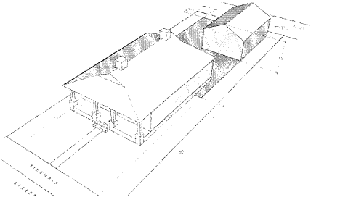
Accessory Dwelling (Alley Access)
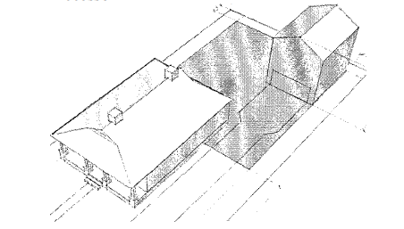
Accessory Dwelling (Garage Apartment w/ Alley Access)
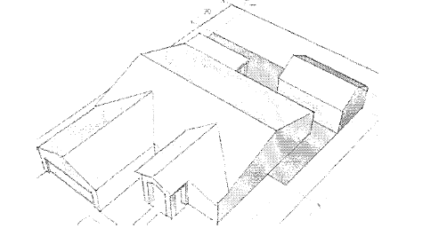
Accessory Dwelling (Modern Suburban Subdivision)

SECTION 7: It shall be unlawful for any person, firm or corporation to violate, or cause the violation of, any provision of this ordinance. Any person, firm or corporation violating any of the provisions in this ordinance shall be guilty of a class 1 misdemeanor, and upon conviction thereof shall be punished by a fine not to exceed $1,000 or by imprisonment for not more than ten days or both fine and imprisonment. Each separate day or part thereof during which any violation of said sections occurs or continues shall be deemed to constitute a separate offense, and upon conviction thereof shall be punishable as herein provided.

Adopted this ________ day of ___________________, 2025.
APPROVED:

____________________ Douglas J. Nicholls

Mayor

ATTESTED:

____________________

Lynda L. Bushong

City Clerk

APPROVED AS TO FORM:

____________________
Richard W. Files

City Attorney

