ORDINANCE NO. O2025-016

AN ORDINANCE OF THE CITY COUNCIL OF THE CITY OF YUMA, ARIZONA, AMENDING CHAPTER 154 OF THE YUMA CITY CODE, REZONING CERTAIN PROPERTY LOCATED IN THE AGRICULTURE (AG) DISTRICT TO THE HEAVY INDUSTRIAL (H-I) DISTRICT, AND AMENDING THE ZONING MAP TO CONFORM WITH THE REZONING

WHEREAS, the City of Yuma Planning and Zoning Commission held a public hearing on April 14, 2025 in Zoning Case No: ZONE- 43671-2025 in the manner prescribed by law for the purpose of rezoning approximately 160 acres of real property hereafter described to the Heavy Industrial (H-I) District as provided in Chapter 154 of the Yuma City Code; and,

WHEREAS, due and proper notice of the public hearing was given in the time, form, substance and manner provided by law, including publication of notice of the hearing in the Yuma Sun on March 21, 2025; and,

WHEREAS, the City Council has considered the recommendation of the Planning and Zoning Commission to approve the rezoning in Case No: ZONE- 43671-2025 and the probable impact on the cost to construct housing for sale or rent that may occur as a result of this rezoning, and finds that the recommendation complies with and conforms to the goals and objectives of the Yuma General Plan, as amended.

NOW THEREFORE, BE IT ORDAINED by the City Council of the City of Yuma as follows:

SECTION 1: That the following described real property, depicted in Exhibit A, attached:

The West Half of the Southwest Quarter of Section 16, Township 10 South, Range 23 West of the Gila and Salt River Base and Meridian, City of Yuma, Yuma County, Arizona and being more particularly described as follows:
Blocks 12 and 13 per “Persian Gardens, Tract No. 1” according to the plat as recorded in the Yuma County Recorder’s Office, Yuma County, Yuma Arizona, in Book 2, Page 24, Dated: 9-28-1926; and
The East Half of the Southwest Quarter of Section 16, Township 10 South, Range 23 West of the Gila and Salt River Base and Meridian, City of Yuma, Yuma County, Arizona and being more particularly described as follows:
Blocks 11 and 14 per “Persian Gardens, Tract No. 1” according to the plat as recorded in the Yuma County Recorder’s Office, Yuma County, Yuma Arizona, in Book 2, Page 24, Dated: 9-28-1926.
Containing a total of 6,969,600 square feet or 160.0 acres more or less.
shall be placed in the Heavy Industrial (H-I) District, as defined by Chapter 154 of the Yuma City Code as amended; that upon this Ordinance becoming final, the described real property shall be subject to all rules, regulations and requirements of Chapter 154 of the Yuma City Code, as amended, pertaining to the Heavy Industrial (H-I) District and that the zoning map adopted under Chapter 154 of the Yuma City Code, as amended, is ordered to be changed and amended so as to show that the real property described in this Ordinance will be located within the Heavy Industrial (H-I) District.

SECTION 2: That the following conditions (s) must be met and/or completed in order for the zoning amendment to be final:

- The conditions listed below are in addition to City codes, rules, fees and regulations that are applicable to this action.

- The Owner’s signature on the application for this land use action shall constitute a waiver of any claims for diminution in value pursuant to A.R.S. § 12-1134. 3.

- Owner/developer shall dedicate rights-of-way, such that the City of Yuma obtains 40 feet half width (collector street standard) along:
- 96th Street (County 19th Street)
- 4th Avenue
- 92nd Street (County 18 ½ Street)
- Avenue A

- Owner/Developer shall dedicate corner triangles with a leg length of 40 feet and additional right-of-way for turn lane widening, as per Figure 3 of the 2005/2007 Major Roadways Plan with a collector street standard, at the four outside corners of the property involved in the rezone request.

- Owner/Developer shall record a waiver acknowledging that there is no City water, City sewer, or City emergency services within the local development area. Emergency services response times will be extended due to the travel distance from existing City of Yuma Police and Fire stations, or other mutual aid stations, to this location, and services will be limited due in part due to the lack of water infrastructure.

SECTION 3: With the exception of Condition 2, each of the conditions listed above shall be completed within two (2) years of the effective date of the rezoning ordinance or prior to the issuance of a building permit or business license for this site, whichever occurs first. If the conditions of approval are not completed within the above time frame, then the rezone shall be subject to A.R.S. § 9-462.01.

Adopted this __________ day of ____________________, 2025.

APPROVED:

_________________________
Douglas J. Nicholls
Mayor

ATTESTED:

_________________________
Lynda L. Bushong
City Clerk

APPROVED AS TO FORM:

_________________________
Richard W. Files
City Attorney

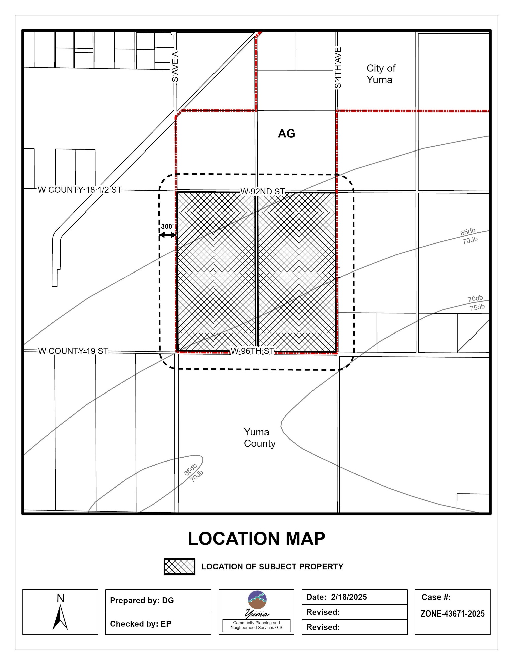
Exhibit A

